

SOFTWARE CONSTRUCTION
PHASE II :ANALYSIS AND DESIGN

SUBMITTED BY:
TEAM LEAD: KHANSA FAROOQ (00000471827)
SARA AMIN (00000462417)
HAMNA MUSHTAQ (00000486820)
ALI IMRAN (00000455268)
FAIZA MALIK (00000475313)
COURSE:
BESE- 29 ‘C’
SUBMITTED TO:
LECTURER FAWAD KHAN
DATE OF SUBMISSION:
3-DECEMBER-2025(WEDNESDAY)

Table of Contents
- Introduction
1.1 Purpose of Phase 2
1.2 Scope & Objectives
1.3 Overview of the System
- Tools, Technologies, and Frameworks
2.1 Frontend Technologies
2.2 Backend / Services
2.3 Database & Storage Options
2.4 APIs, Libraries & Authentication
2.5 IDEs, Testing & CI Tools
- Architecture & Design Patterns
3.1 Overall System Architecture (SOA + Micro-Frontend concept)
3.2 MVC adaptation in React
3.3 Service Object Pattern & Adapter Pattern (services layer)
3.4 Observer Pattern (Notifications & Context)
3.5 Circuit Breaker / Fallback (Simulation Mode)
3.6 Security & Key-Management Decisions
- Use Case Modeling
4.1 Actors of the System
4.2 Main Use Case Diagram
4.3 Detailed Descriptions of 5 Key Use Cases
- Class Diagrams
5.1 Class Diagram Overview
5.2 Key Classes with Attributes & Methods
5.3 Relationships, Aggregation & Dependencies
- Sequence Diagrams (Object Interactions)
6.1 Sequence: View Real-Time AQI
6.2 Sequence: Predict AQI (3-day Forecast)
6.3 Sequence: Smog Image Analysis (Bio-Vision)
6.4 Sequence: Notifications (Heartbeat & Alerts)
6.5 Sequence: Safe-Zone Computation
- Deployment Diagram
7.1 Nodes & Artifacts (Browser, Hosting, Serverless)
7.2 External Services & Network Flows
7.3 Deployment Notes & Security Considerations
- Design Rationale & Tradeoffs
8.1 Why these patterns & tools?
8.2 Performance, scalability & cost tradeoffs
8.3 Future extensibility (adding DB, dedicated backend)
- Conclusion & Readiness for Implementation (Phase 3)
9.1 Summary of outputs from Phase 2
9.2 Risks & Mitigation
9.3 Next steps & Milestones

1. Introduction
1.1 Purpose
The purpose of Phase 2 is to convert the proposed Air Quality Insight System into a structured software design. This phase focuses on transforming ideas into formal engineering models using standard UML notation. By completing this phase, the system becomes ready for implementation because its architecture, interactions, and components are clearly defined.
This stage ensures that the design follows proper software engineering principles such as modularity, separation of concerns, and reusability.
1.2 Scope & Objectives
The scope of this phase covers the full design blueprint of the system. The main objectives are:
- selecting the tools, technologies, and development frameworks
- modeling system behavior using use case diagrams and descriptions
- defining system structure through class diagrams
- illustrating object interactions using sequence diagrams
- designing how the system will be deployed in a real or simulated environment
These objectives provide a complete technical foundation so developers can implement the system without ambiguity.
1.3 Overview of the System
The Air Quality Insight System is a web-based application that provides real-time air quality monitoring, AQI forecasting, smog analysis, and dynamic pollution-safe zoning. The system interacts with external data sources such as the IQ Air API to fetch live pollution levels and uses machine learning APIs to analyze smog. It features a modular interface where each region of Pakistan functions as a self-contained module, allowing scalable expansion.
The system is designed as service-oriented, meaning each major feature AQI Retrieval, AQI Prediction, Bio-Vision, Notifications, and Safe Zone Finder works independently while sharing a common frontend. This structure makes the application easy to maintain, extend, and integrate with new services in the future.
2. TOOLS, TECHNOLOGIES, AND FRAMEWORKS
This section describes the selected tools, technologies, and frameworks for designing the Intelligent Air Quality Index (AQI) Monitoring and Notification System. The choices focus on scalability, modularity, and maintainability, while aligning with a modern web-based system design.
2.1 Frontend Technologies
- React 18 (SPA Framework): The frontend is designed as a single-page application (SPA) using React for component-based modularity, efficient rendering via Virtual DOM, and a declarative approach to UI design.
- TypeScript (TSX): Ensures strong typing and maintainable code. Facilitates clear contracts between components and services, reducing runtime errors.
- Tailwind CSS: Utility-first framework for designing responsive and visually consistent layouts. Supports theming, animations, and rapid prototyping.
- Map Visualization: Leaflet.js is used for interactive maps, enabling location-based AQI visualization and safe-zone guidance.
2.2 Backend / Services
- Service Layer Architecture: The system separates business logic from the UI via service modules (aqiService.ts and geminiService.ts). This design supports modularity, maintainability, and easier testing.
- Service Design Patterns: Includes Adapter Pattern for transforming external API responses into internal models, and Circuit Breaker / Fallback Pattern to ensure system resilience in case of API failures.
- No Dedicated Backend Server: All service logic runs as modular frontend services, simulating backend interactions at the design level.
2.3 Database & Storage Options
- Design Consideration: The system is designed to support cloud-based storage for historical AQI data and user-specific settings.
- Data Organization: Logical separation of data types such as real-time air quality readings, forecasts, and user health profiles.
- Scalability: Supports potential integration with SQL or NoSQL databases in the future to enable caching, replication, and efficient query performance.
2.4 APIs, Libraries & Authentication
- APIs:
  - AQI and pollution data via third-party environmental APIs.
  - Geocoding services (OpenStreetMap) for location searches.
  - AI-based analysis and predictions via Google Gemini API.
- Libraries: Recharts for interactive charts, Leaflet plugins for heatmaps and marker clustering.
- Authentication & Security Design: Role-based access and API key management are incorporated at the service layer, ensuring secure and controlled access to data and AI services.
2.5 IDEs, Testing & CI Tools
- IDE: Modern web IDE (e.g., VS Code, WebContainer) for TypeScript development, modular architecture, and static analysis.
- Testing Approach: Design anticipates unit and integration testing of service modules and UI components.
- Continuous Integration (CI): System design supports automated builds, ensuring consistency between development, testing, and deployment environments.
3. ARCHITECTURE & DESIGN PATTERNS
The Intelligent Air Quality Index (AQI) Monitoring and Notification System is designed to deliver real-time, actionable air quality data to users through a modular, resilient, and scalable architecture. This section details the architectural structure, design patterns, and design decisions that ensure maintainability, flexibility, and robustness.
3.1 Overall System Architecture (SOA + Micro-Frontend Concept)
The system leverages a Service-Oriented Architecture (SOA) layered with a Micro-Frontend approach to modularize both backend and frontend logic.
- Service-Oriented Architecture (SOA): The application separates its core functionality into independent service modules, such as aqiService.ts and geminiService.ts. Each service is responsible for handling a specific set of operations like fetching AQI data, predicting air quality, or analyzing visual input from users. By decoupling the UI from these services, the system achieves:
  - Maintainability: Services can be modified or upgraded independently.
  - Scalability: New services or APIs can be integrated without affecting existing modules.
  - Testability: Services can be tested in isolation.
- Micro-Frontend Concept: Each major feature (MapView, ForecastsView, PollutionSourcesView, SmogScannerView) behaves as an independent module with its own internal state and logic. Advantages include:
  - Independent Development: Teams can work on different views without conflicts.
  - Reusability: Modules can be reused in other projects or dashboards.
  - Data Logging & Analytics ServiceFlexibility: Modules can be dynamically loaded based on user needs.
External APIs
Storage
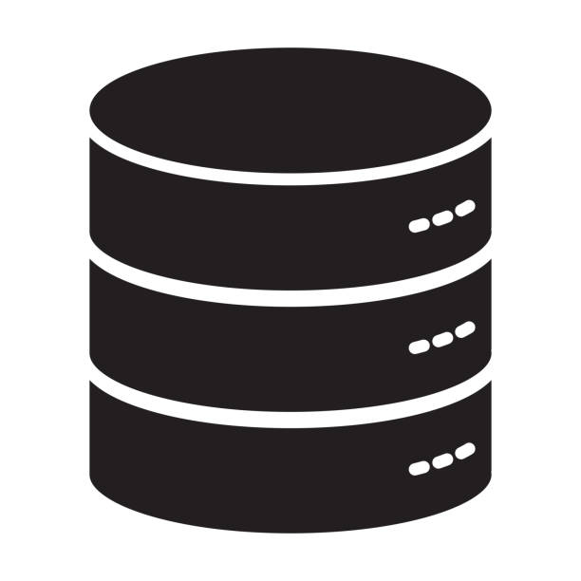
API Adapters
Data Logging & Analytics Service
Location / Geocoding Service
Forecasting Service
Vision Analysis Service
AQI Service
Service Layer

User Interface (UI Layer)
DashboardLayout, MapView, ForecastsView, PollutionSourcesView, SmogScannerView, PersonalizedAdviceView.

3.2 MVC adaptation in React
The system applies Model-View-Controller (MVC) principles adapted for React:
View Layer (Components):
  - Presentational components like Sidebar.tsx, Header.tsx, and AQIStatCard.
  - Receives data via props or AppContext, purely for rendering.
Controller Layer (Smart Components & Context):
  - Smart views like MapView.tsx and ForecastsView.tsx manage user interaction and state updates.
  - AppContext.ts acts as the global store (singleton), controlling shared state, notifications, and user preferences.
Model Layer (Services / Data):
Encapsulates API calls (aqiService.ts, geminiService.ts) and adapts raw data into structured models (AQIModel, VisionAnalysisResult

Updates View
Request processed
Manipulates
Input From User
Model Layer
Fetches and processes data, returns structured models
Controller Layer
Handles user input, triggers services, updates Context

View Layer (UI Components)
MapView, ForecastsView, DashboardLayout, Charts.

3.3 Service Object Pattern & Adapter Pattern (services layer)
These patterns ensure clean separation of concerns and decoupling of frontend from backend:
Service Object Pattern:
  - Each service (AQIService, GeminiService, LocationService) handles a specific domain of operations.
  - Provides a single interface for the UI to access structured data.
Adapter Pattern:
Converts raw external API responses into internal domain models.
Examples: AQIAdapter → AQIModel, GeminiAdapter → VisionAnalysisResult.
Data Flow:
API → Adapter → Service → UI / Controller
Circuit Breaker or Fallback logic ensures resilience if APIs fail.
UI
Services
Adapters
External APIs

3.4 Observer Pattern (Notifications & Context)
The application employs the Observer Pattern to handle real-time notifications, including AQI alerts, system messages, and user-specific updates, ensuring that the UI components remain synchronized with changes in the global application state.
Publisher:
AppContext acts as the centralized state store and publisher. It manages global state such as user location, health profile, notifications, and theme settings.Any update in AppContext triggers events to notify subscribed components.
Subscribers:
Components that react to published events include:
- UI Components: Header, ToastContainer, InboxView
- Dashboard Views: DashboardView, MapView, ForecastsView
- User-Specific Modules: PersonalizedAdviceView, SafePlacesView, ProfileModal
Flow:
- An event occurs in AppContext (e.g., new AQI alert or system message).
- The publisher notifies all subscribers.
- Each subscriber updates its state/UI based on the new data.
- Browser-native notifications (via Notification API) can also be triggered for immediate user alerts.
Benefits:
- Decoupling: Subscribers are independent of the data source; they only react to updates.
- Real-Time Updates: Ensures that critical alerts propagate immediately across the UI.
- Scalability: New subscribers can be added without modifying existing publisher logic.
MapView
highlights regions with high AQI.
ProfileModal
may update user-specific alert settings dynamically.
Publisher
AppContext
PollutionSourcesView updates charts if new pollutant data arrives.
PersonalizedAdviceView
updates health advice based on new AQI alerts.
ForecastsView
updates predicted AQI trends when data changes.
DashboardView – updates AQI stats or charts in real time.
InboxView
shows notification history or detailed messages.
ToastContainer
pops up real-time notification messages.

3.5 Circuit Breaker / Fallback (Simulation Mode)
To ensure system resilience against external API failures or quota limitations, the application implements a Circuit Breaker / Fallback mechanism within the service layer.
Implementation:
Each service object (e.g., AQIService, GeminiService) wraps API calls with a circuit breaker that monitors the availability and responsiveness of external endpoints.
Operational Flow:
- Success Path: When the API is available and responsive, the service fetches real-time data and delivers it to the frontend components.
- Failure Path: If the API is unreachable, exceeds quota, or returns an error, the circuit breaker automatically switches to Simulation Mode, returning high-fidelity mock data. This ensures that the system continues to function seamlessly without interrupting the user experience.
Benefits:
- Reliability: Prevents system crashes due to API failures.
- Continuity: Users continue to receive meaningful data even during outages.
- Testability: Simulation data allows developers to test components without relying on live API access.

AQI Service
Success
Failure
Simulation Data
API

UI Layer

4.USE CASE MODELING
4.1 Actors of the System
- Primary Actor:
User (Citizen / App User)
This is the human interacting with the AQI Monitoring and Safety Assistant System. The user performs tasks such as viewing AQI, checking safe locations, and receiving health advice.
- Secondary Actors:
External AQI API
An external data provider responsible for delivering real-time AQI values, pollutant breakdowns, and forecast information.
- Notification Service
This represents internal or OS-level notification mechanisms used by the system to deliver alerts (e.g., hazardous AQI level warnings).
4.2 Main Use Case Diagram
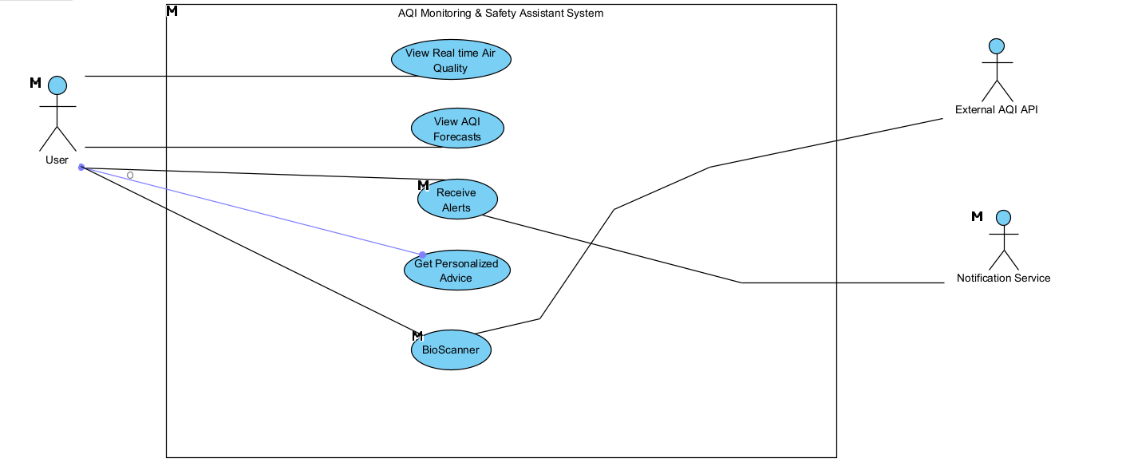

Use Case: View Real Time AQI Dashboard | ID: UC0 | Priority: Very High
Description: | The user opens the application to view the real-time AQI Dashboard. The system retrieves live air-quality data (AQI, pollutants, humidity, temperature), processes it through service modules, and presents an updated dashboard with alerts, charts, and recommendations.
Actor: | User (Primary)  AQI API / Backend Services (Secondary),Notification Service(Secondary)
Trigger: | User clicks the "Login" button
Preconditions: | - User has internet access.  - AQI API or fallback simulation mode must be available.  - Application must be running.
Normal Course: | - System loads the Dashboard interface.  - System triggers AQIService to fetch real-time AQI data.  - AQIService sends request to AQI API.  - API returns raw AQI data (pollutants, readings, timestamps).  - Adapter converts raw API data into internal models.  - Dashboard updates all widgets: AQI level, pollutant breakdown, temperature, humidity.  - If AQI is hazardous, the system notifies the user through AppContext (Observer Pattern).  - User views live results, alerts, and recommendations.
Alternative Flow (API Failure): | A1. API request fails.  A2. Circuit Breaker activates → switches to Simulation Mode.  A3. System loads mock high-fidelity AQI data.  A4. Dashboard still shows meaningful information without crashing.
Postconditions: | - User successfully views current AQI and environment data.  - Dashboard state is updated and cached.  - Any alerts are logged and displayed to the user.
Extends: | UC6 Receive Alerts (if air quality becomes dangerous)
Includes: | - Data Fetching  - Adapter Conversion  - Notification Dispatch (Observer Pattern)

4.3 Detailed Descriptions of 5 Key Use Cases
Use Case 1: View Air Quality
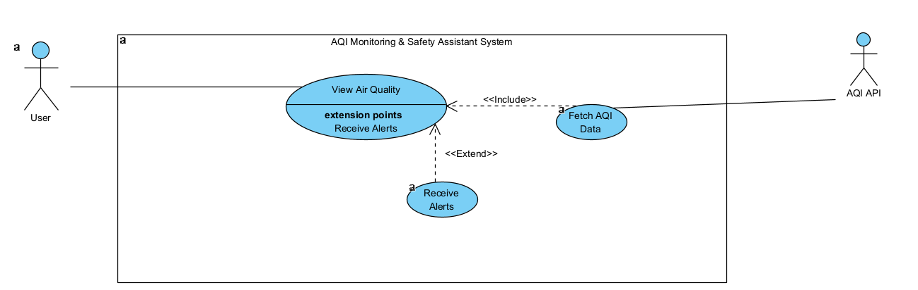

Use Case: View Air Quality | ID: UC1 | Priority: High
Description: | Allows the user to see the current air quality index (AQI) for their location or any selected city. The system fetches real-time data from the AQI API and displays it in an interactive dashboard.
Actor: | User (Primary)  AQI API / Backend Services (Secondary)
Trigger: | User selects a city or requests current AQI data on the dashboard.
Preconditions: | - User is logged in  - device has internet connection.
Normal Course: | 1. User clicks on "View AQI" on the dashboard.  2. System fetches data from AQI API.  3. AQIService adapts data into internal AQIModel.  4. DashboardView and MapView display AQI information visually.  5. User can hover or click markers to see detailed pollutant data..
Alternative Flow (API Failure): | If AQI API fails, system enters Simulation Mode (returns mock data).
Postconditions: | AQI information is displayed; user can make informed decisions about outdoor activities.
Extends: | Fetch AQI Data
Includes: | Receive Alerts (if AQI exceeds thresholds)

Use Case 2: Check Safe Places
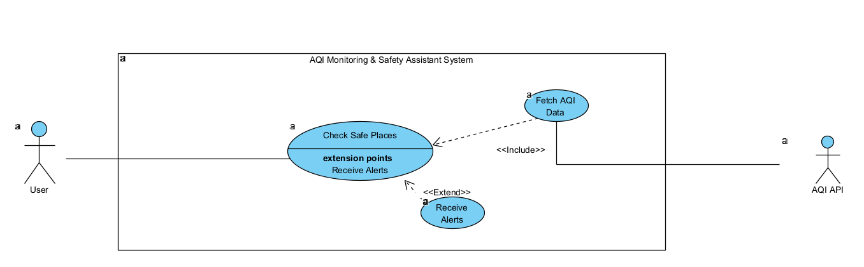

Use Case: Check Safe Places | ID: UC2 | Priority: High
Description: | Allows the user to view locations with lower pollution levels (safe zones) based on AQI data. The system highlights areas suitable for outdoor activities.
Actor: | User (Primary)  AQI API / Backend Services (Secondary)
Trigger: | User clicks on "Safe Places" tab
Preconditions: | User is logged in device has internet connection.
Normal Course: | 1. User clicks on "View AQI" on the dashboard.  2. System fetches data from AQI API.  3. AQIService adapts data into internal AQIModel.  4. DashboardView and MapView display AQI information visually.  5. User can hover or click markers to see detailed pollutant data.
Alternative Flow (API Failure): | If AQI API fails, system uses Simulation Mode to display mock safe zones.
Postconditions: | Safe locations are displayed for user reference; user can plan activities safely.
Extends: | Fetch AQI Data
Includes: | Receive Alerts (if user is in unsafe zone unexpectedly)

Use Case 3 :Predict AQI / Forecast
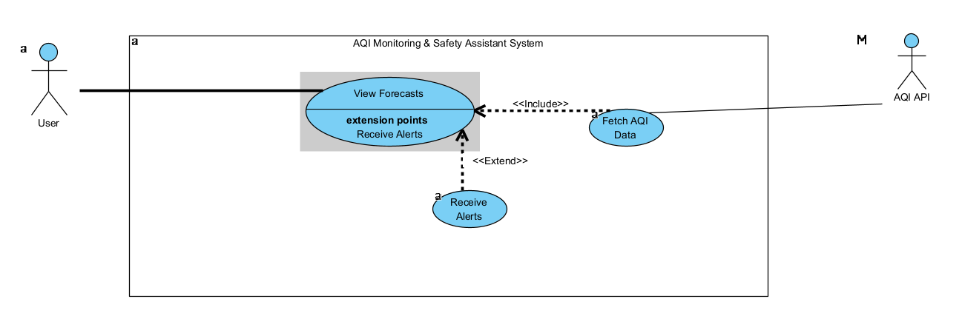

Use Case: Predict AQI / Forecast | ID: UC3 | Priority: High
Description: | Allows the user to view predicted AQI for the next 3 days using machine learning models. Helps users plan outdoor activities safely.
Actor: | User (Primary)  AQI API / Backend Services (Secondary)
Trigger: | User selects “Forecast” on the dashboard.
Preconditions: | User has internet access; system has historical AQI data.
Normal Course: | 1.User clicks on "Forecast" tab.  2. System fetches historical AQI from AQI API.  3. Prediction models (Random Forest / Decision Tree) generate forecast.  4. ForecastsView displays AQI trends in charts.  5. User can analyze trends or compare with previous days.
Alternative Flow (API Failure): | If AQI API fails, system uses simulation/historical data for prediction.
Postconditions: | User sees forecasted AQI data.
Extends: | Fetch Historical AQI Data
Includes: | Receive Alerts (if forecasted AQI is hazardous)

Use Case 4: Personalized Advice
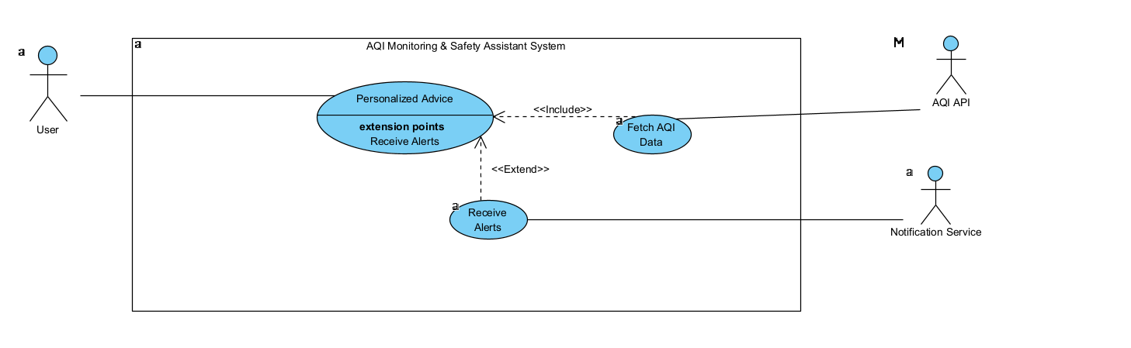

Use Case: Personalized Advice | ID: UC4 | Priority: Medium
Description: | Provides recommendations based on the user’s health profile and current AQI. Advice may include limiting outdoor activity, wearing masks, or avoiding high-pollution zones.
Actor: | User (Primary)  AQI API ,Notification Service(Secondary)
Trigger: | User opens the “Advice” tab or system triggers alert.
Preconditions: | User profile exists; current AQI is available.
Normal Course: | 1. User clicks on "Personalized Advice".  2. System retrieves AQI and health profile.  3. Advice engine generates recommendations.  4. PersonalizedAdviceView displays actionable tips.  5. Notification System may push alerts if urgent.
Alternative Flow (API Failure): | If AQI is unavailable, advice is based on historical trends.
Postconditions: | User receives personalized recommendations for safe activities.
Extends: | Fetch AQI Data, Retrieve User Profile
Includes: | Receive Alerts

Use Case 5 :Bio-Vision / Smog Scanner
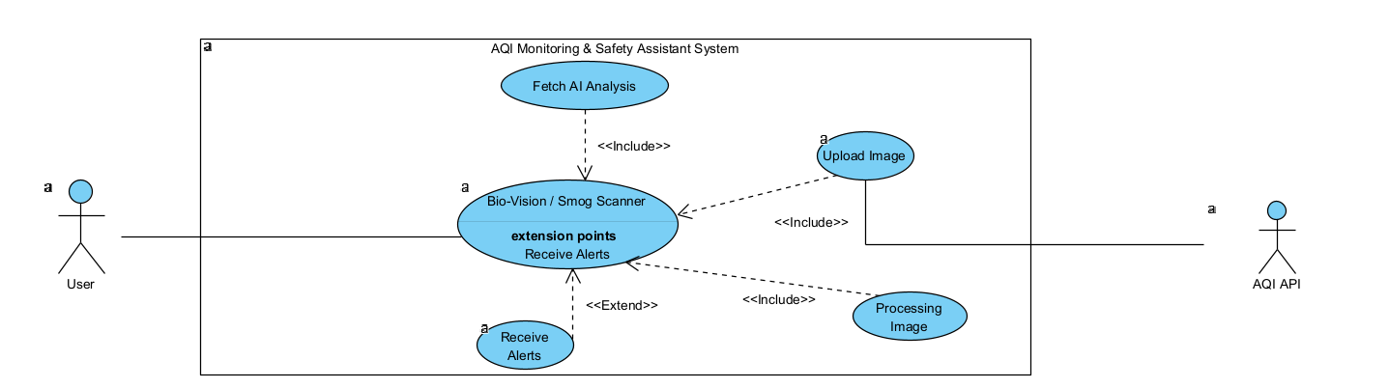

Use Case: Bio-Vision / Smog Scanner | ID: UC5 | Priority: Medium
Description: | Allows the user to upload images for pollution analysis. System uses AI (GeminiService) to detect smog type, severity, and visual AQI..
Actor: | User (Primary)  AQI API ,Notification Service(Secondary)
Trigger: | User uploads an image via dashboard.
Preconditions: | User has internet access; AI service available.
Normal Course: | 1. User uploads an image.  2. BioVisionView sends image to GeminiService.  3. GeminiAdapter processes AI output into VisionAnalysisResult.  4. BioVisionView renders analysis for user.  5. Alerts triggered if AQI visually detected is hazardous.
Alternative Flow (API Failure): | If AI service fails, system uses simulation data for approximate analysis.
Postconditions: | Visual AQI analysis is displayed.
Extends: | Upload Image, Process Image, Fetch AI Analysis
Includes: | Receive Alerts (if visual AQI is high)

5. CLASS DIAGRAMS
5.1 Class Diagram Overview
The Class Diagram provides a structured representation of the system’s core components, showing how the frontend, service layer, adapters, models, and global state interact.
5.2 Key Classes with Attributes & Methods
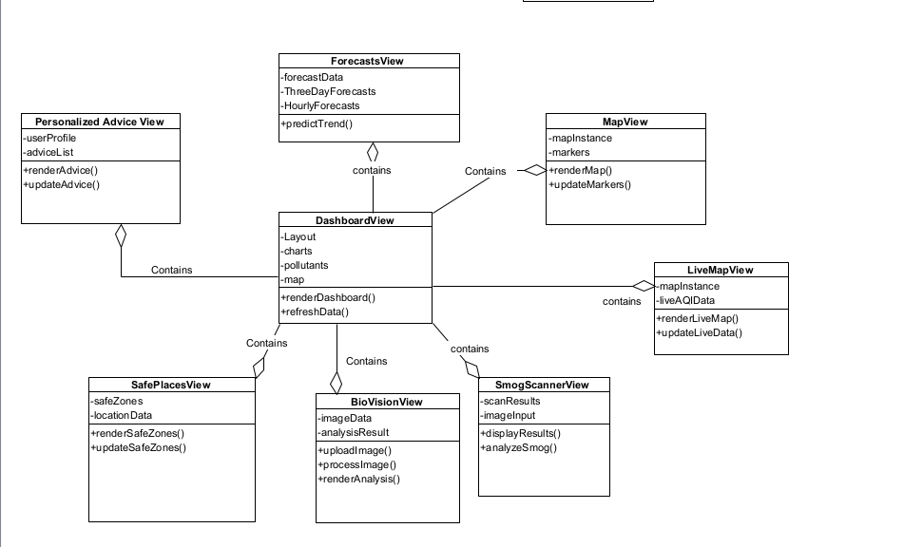
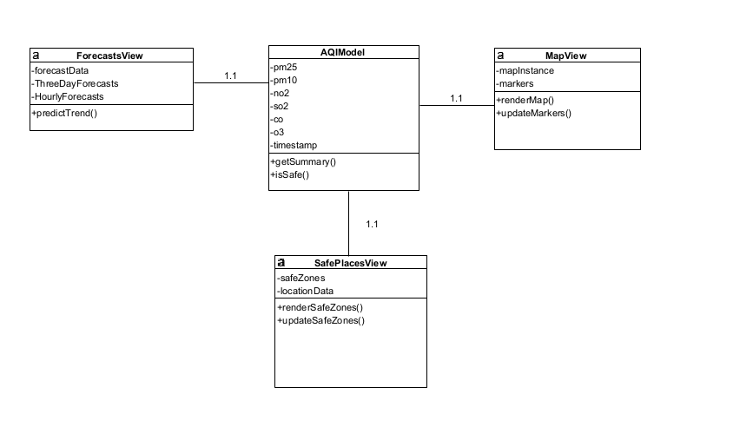
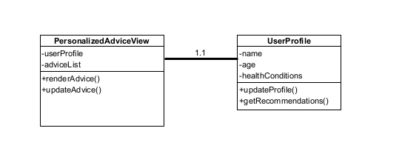
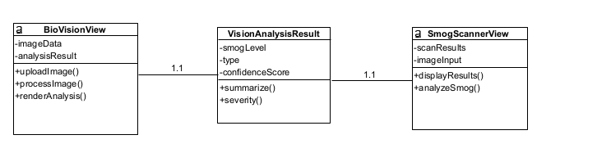
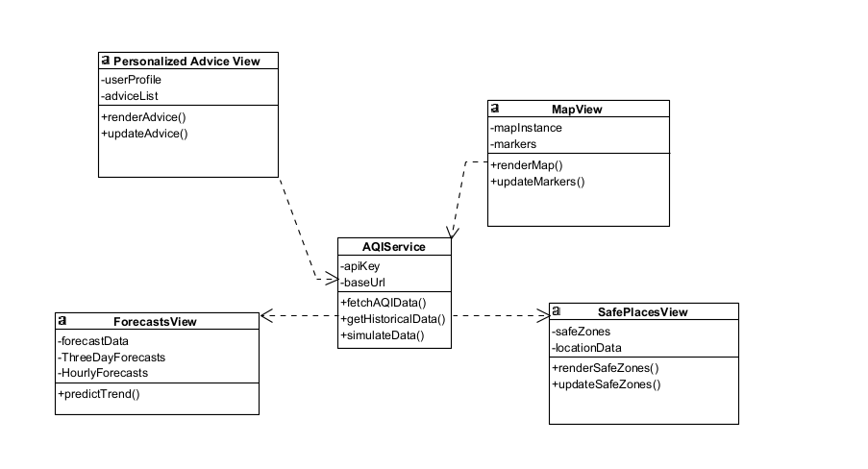
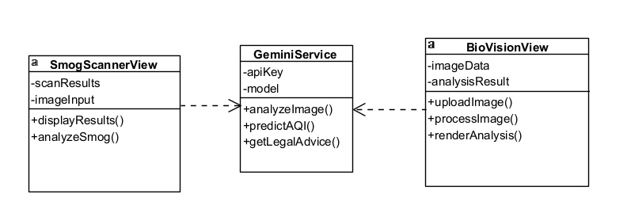
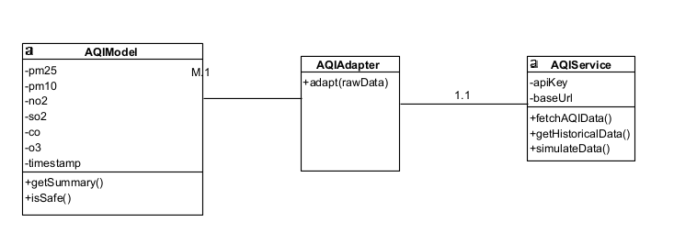
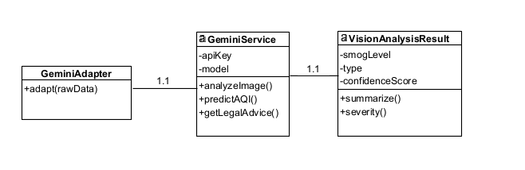
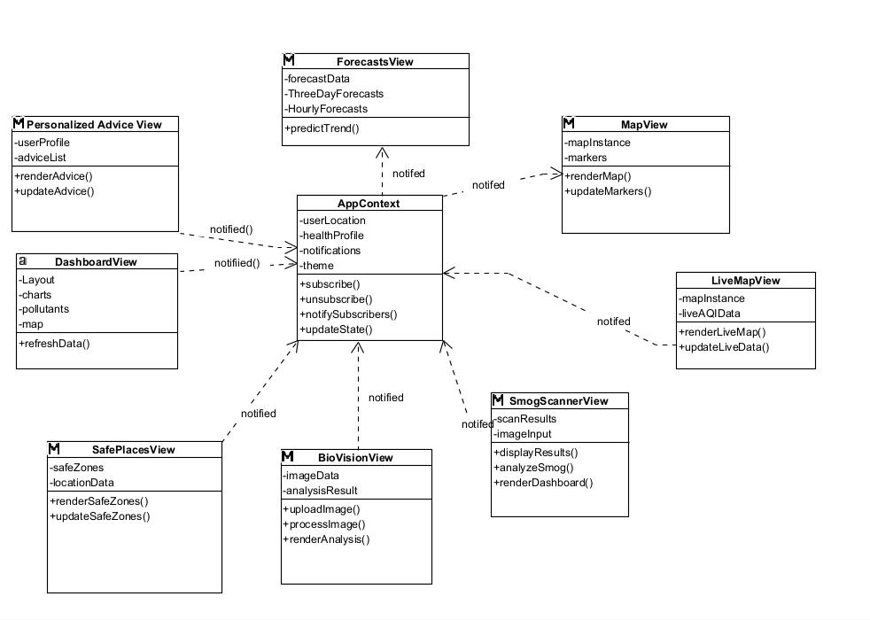
6. SEQUENCE DIAGRAMS (OBJECT INTERACTIONS)
6.1 Sequence: View Real-Time AQI
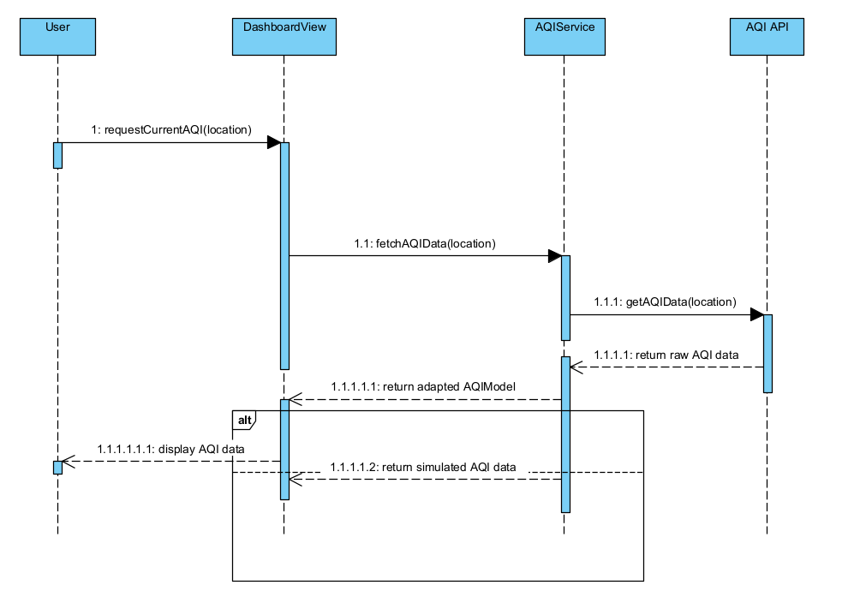
6.2 Sequence: Predict AQI (3-day Forecast)
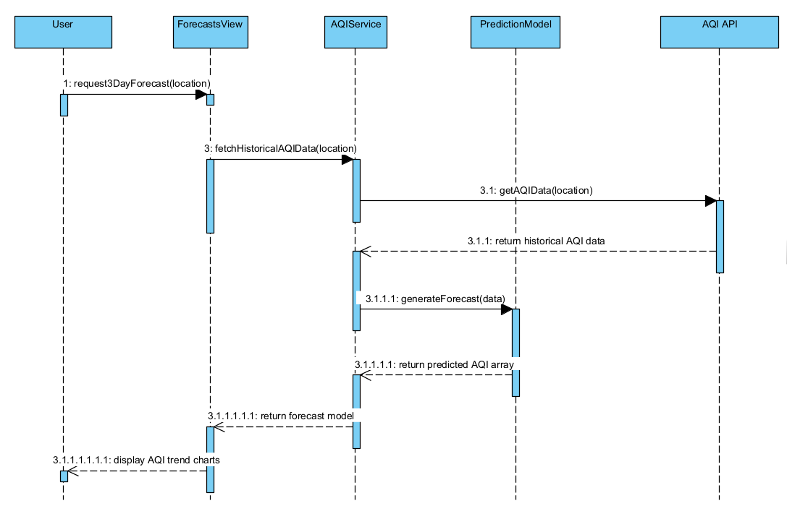
6.3 Sequence: Smog Image Analysis (Bio-Vision)
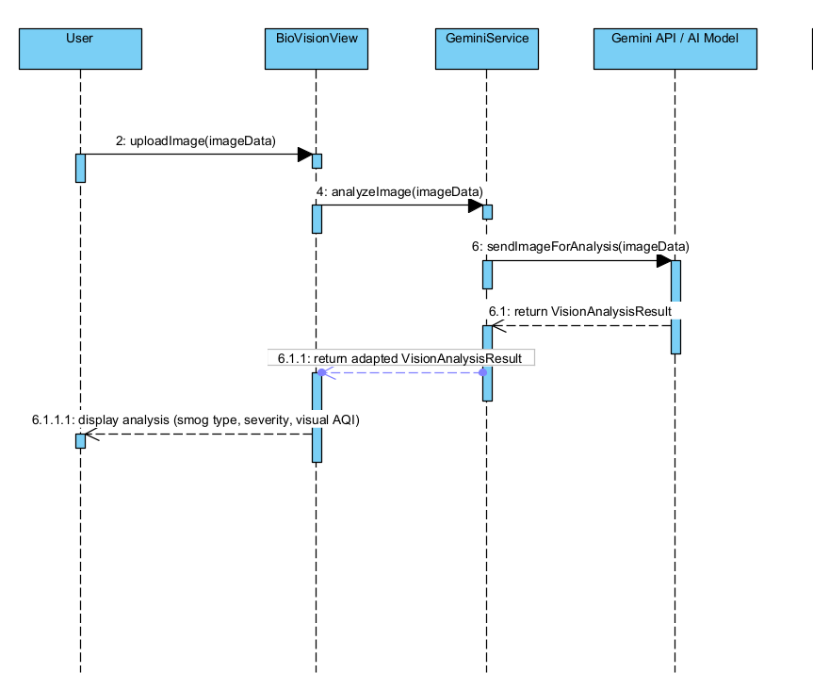
6.4 Sequence: Notifications (Heartbeat & Alerts)
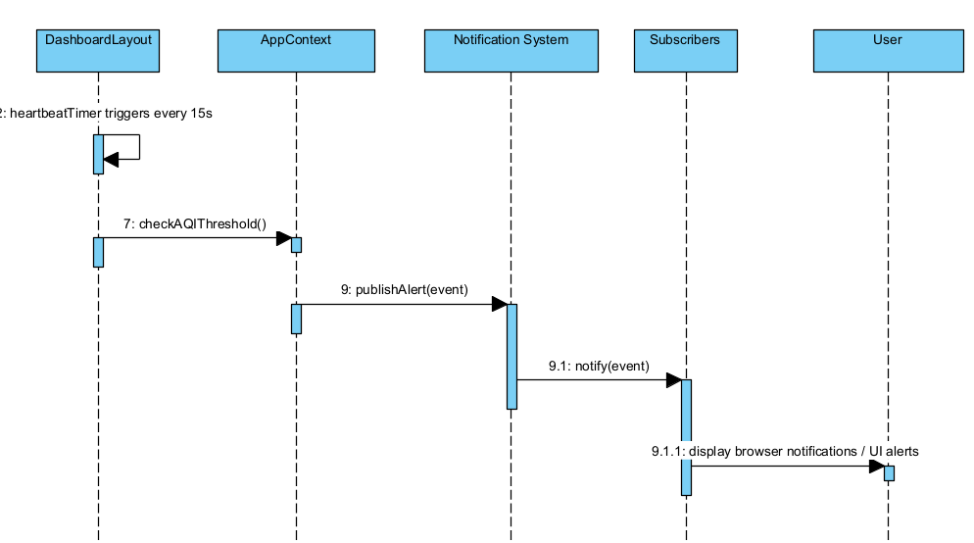
6.5 Sequence: Safe-Zone Computation
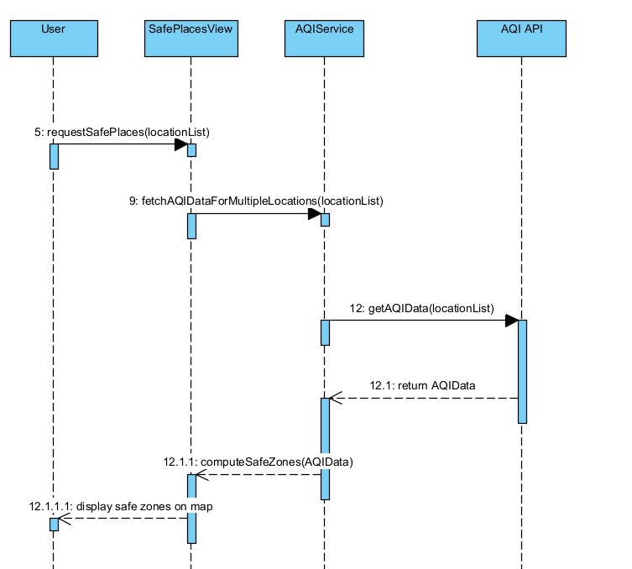
7. DEPLOYMENT DIAGRAM
7.1 Nodes & Artifacts
The deployment of the Intelligent AQI Monitoring System is structured to separate the user interface, backend services, external APIs, and data storage. This ensures scalability, maintainability, and resilience.
Node | Type | Artifacts / Components
User Device (Browser / Client) | Node | Browser (Chrome / Edge)  Frontend SPA (React 18 via CDN)  Tailwind CSS runtime
Hosting / Web Server | Node | Static hosting for SPA (Vite / WebContainer)  Serves HTML, JS, and CSS files
Serverless Backend / Services | Node | AQIService  GeminiService  API Adapters (AQIAdapter, GeminiAdapter)  Circuit Breaker / Simulation Mode logic
External APIs / Cloud Services | Node | AQI Provider APIs  Google Gemini API  OpenStreetMap / CartoDB tiles
Data Storage | Node | Historical AQI Data  User profiles  Simulation / Mock data

7.2 External Services & Network Flows
The deployment diagram shows how components communicate:
- Browser → Hosting / Web Server: Requests SPA files (HTML, JS, CSS).
- Browser → Serverless Services: Fetch requests (REST API) to AQIService and GeminiService.
- Serverless Services → External APIs: AQIService calls AQI API, GeminiService calls Gemini AI API.
- Serverless Services → Data Storage: Store and retrieve historical AQI, user profiles, or simulation data.
- Notification System: AppContext triggers notifications → browser UI components → User.
7.3 Deployment Notes & Security Considerations
- Browser Security: HTTPS is used for all data transmission.
- API Key Management: API keys (e.g., Google Gemini) are stored in secure serverless environment variables.
- Serverless Hosting: SPA and services can be hosted on Netlify, Vercel, or StackBlitz-like environments.
- Data Privacy: User profiles and location data are anonymized if logged.
- Resilience: Circuit breaker ensures the system can return simulation data if external APIs fail.
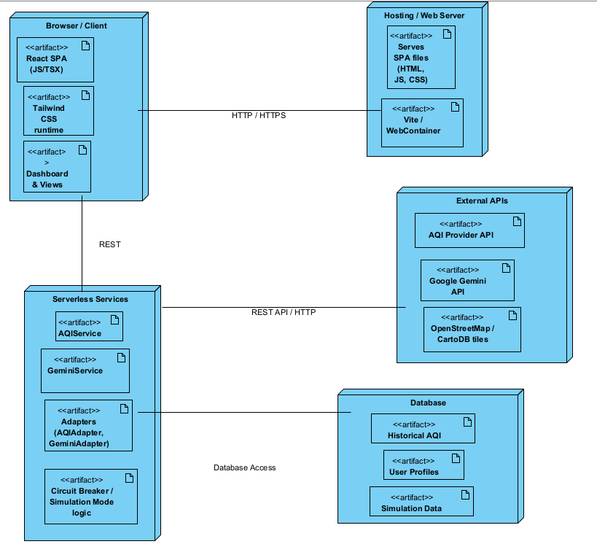

8. DESIGN RATIONALE & TRADEOFFS
8.1 Why These Patterns & Tools?
The architecture uses static hosting and serverless services to keep the system simple, fast, and low-maintenance. A client-side UI with REST APIs avoids heavy backend infrastructure while still supporting real-time AQI updates. Serverless functions act as small micro-services that fetch and process AQI data on demand, keeping each part modular and easy to update. This approach matches the project’s goal: demonstrating cloud deployment without complex DevOps.
8.2 Performance, Scalability, and Cost Tradeoffs
Serverless compute scales automatically—more users simply trigger more executions—so the system handles traffic spikes smoothly. Static hosting delivers very fast loading times and global availability.
The tradeoffs are mainly related to cost and latency: frequent API calls may increase usage costs, and serverless functions may incur cold-start delays during periods of low activity. However, overall expenses remain lower than running a full dedicated server, making the design practical for academic and lightweight production use.
8.3 Future Extensibility
The architecture is intentionally lightweight but easy to expand. A database can be added to store historical AQI data for trends or predictive analytics. Serverless functions can be extended to interact with storage without architectural changes.
If needed, a dedicated backend (Node.js, Flask, or Spring Boot) can be added later for authentication, caching, or analytics. Since all components communicate via REST APIs, the frontend will not require modifications.
9. Conclusion & Readiness For Implementation (Phase 3)
9.1 Summary of Phase 2
Phase 2 completed all major design artifacts: refined use cases, sequence diagrams, class design, and the deployment architecture. The system’s behavior and structure are now fully mapped and consistent with the required features.
9.2 Risks & Mitigation
Key risks include API downtime, inaccurate predictions, and network instability. These are addressed through simulation fallback, modular services, and caching where possible.
9.3 Next Steps
Phase 3 will implement the designed modules, integrate external APIs, build the UI, and test the system. The final deliverable will be a working prototype ready for evaluation and presentation.

